References

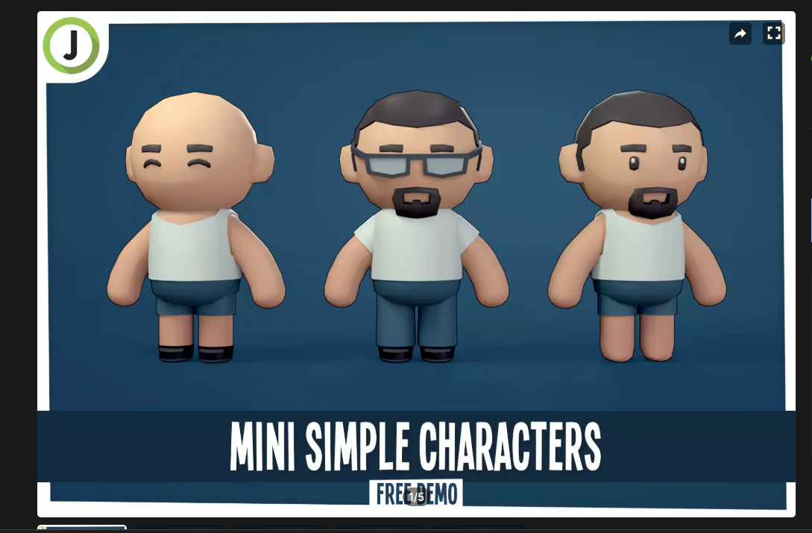

Baltieri, J., 2023. Mini Simple Characters | Free Demo. Available at:<https://assetstore.unity.com/packages/3d/characters/humanoids/mini-simple-characters-free-demo-262799> [Accessed 1 April 2025].

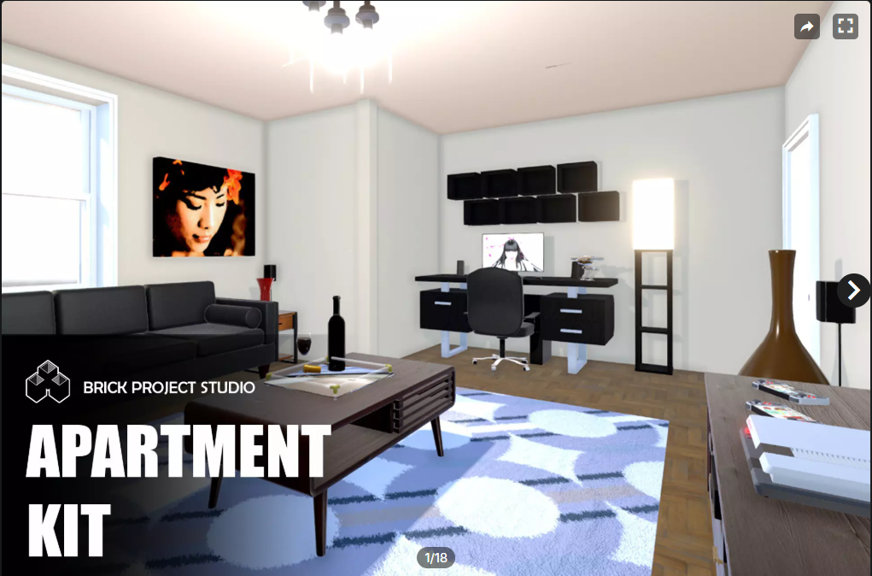

Brick Project Studio, 2023. Apartment Kit. Available at:<https://assetstore.unity.com/packages/3d/environments/apartment-kit-124055> [Accessed 26 March 2025].

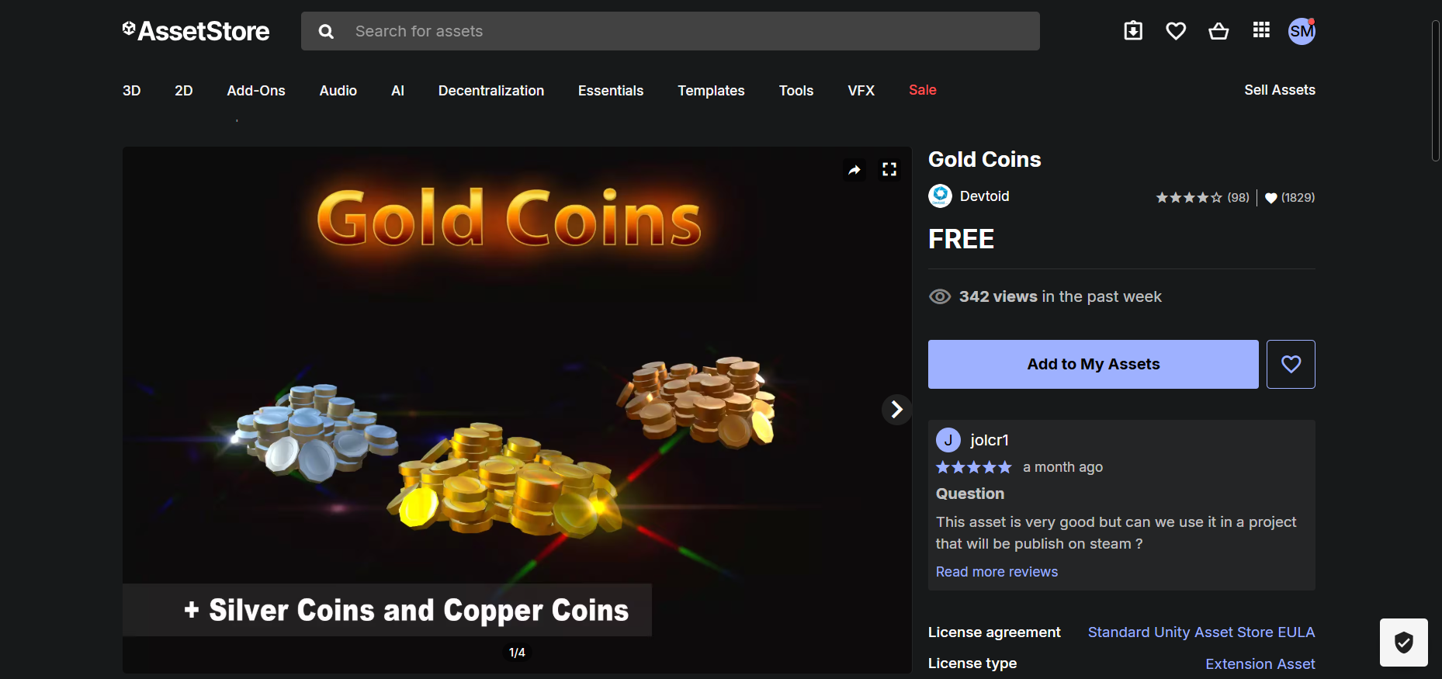

Devtoid, 2019. Gold Coins. Available at:<https://assetstore.unity.com/packages/3d/props/gold-coins-1810> [Accessed 2 April 2025].

Dredstudio. 2025. *Background (Online)*. Available at:<https://dredstudio.com/background/> [Accessed 3 April 2025].

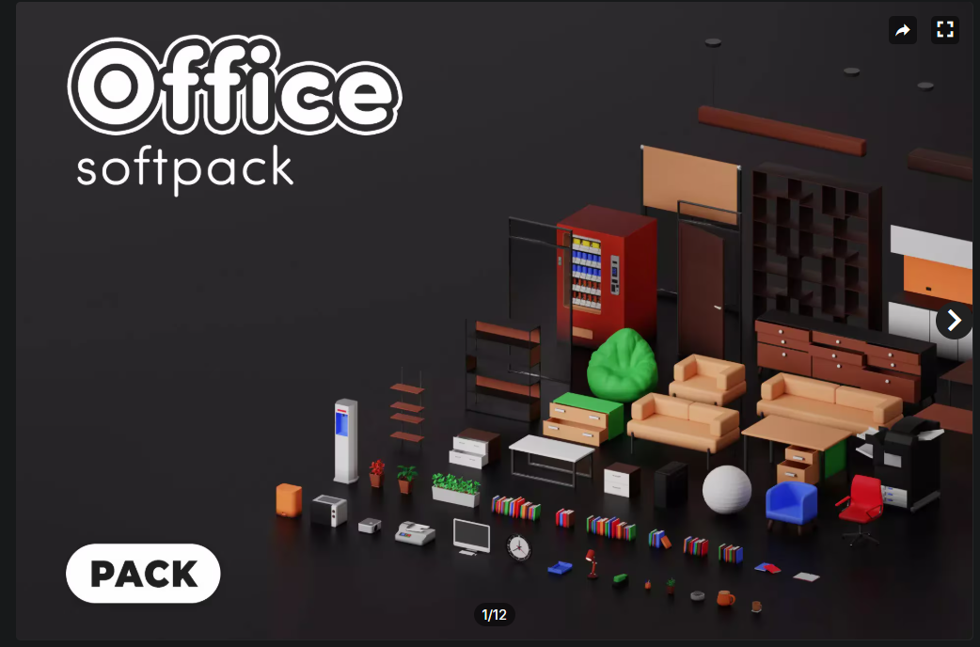

MeshStudy, 2023. *Office Pack – Free.* Available at: [**https://assetstore.unity.com/packages/3d/props/interior/office-pack-free-258600**](https://assetstore.unity.com/packages/3d/props/interior/office-pack-free-258600) [Accessed 3 April 2025].